Git Project

1) git directory created and then initate it as git using git init

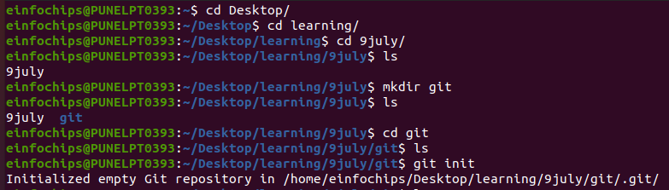
2) copy the http url of repository named “website-project” from github to clone it in local machine

git clone https://github.com/your-username/website-project.git

3) moving in website-project directory and added new directory src and in that directory added new html file.

cd website-project
mkdir src
touch src/index.html
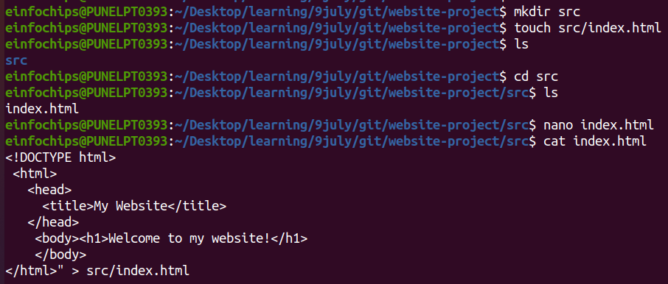
4) add ,commit and push that file

git add .
git commit -m "Initial commit: Added project structure and index.html"
git push origin main

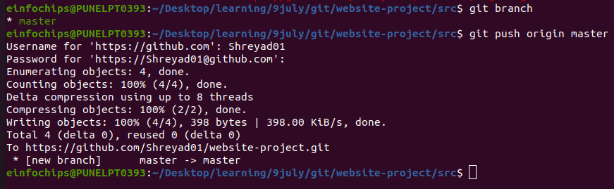

Exercise 1: Branching and Basic Operation

1) create new branch name it “ feature/add-about-page ” then create “ about.html ” file

git checkout -b feature/add-about-page

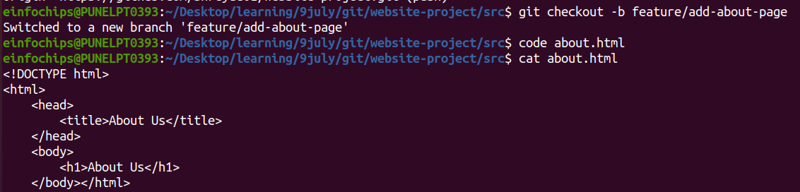

2) add , commit and push

git add src/about.html
git commit -m "Added about page"
git push origin feature/add-about-page
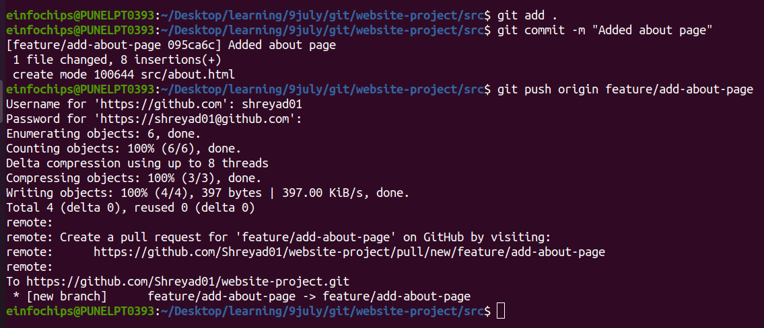

Exercise 2 : Merging and Handling Merge Conflicts

1) go to master branch and create another branch “ feature/update-homepage ”

git checkout main
git checkout -b feature/update-homepage

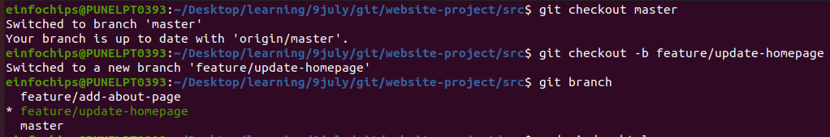
2) update “index.html “ file

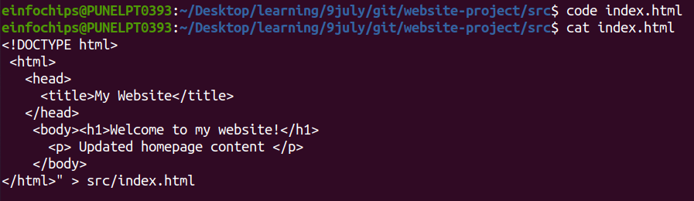

3) add, commit and push changes

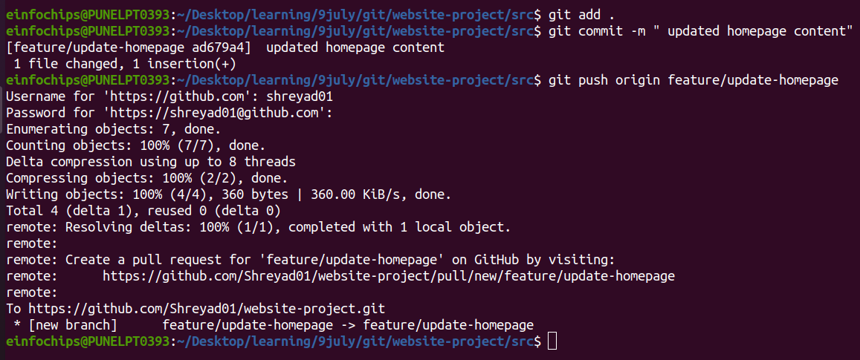

create merge conflict

1) we modify index.html file on feature/add-about-page branch.

git checkout feature/add-about-page

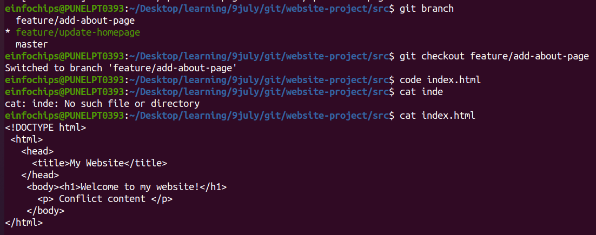
2) then add , commit and push changes.

git add src/index.html
git commit -m "Added conflicting content to homepage"
git push origin feature/add-about-page

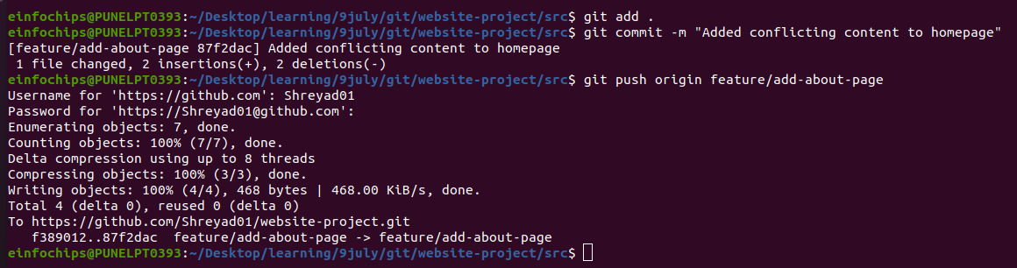

Merge and Resolve conflict

1) To merge feature/add-about-page branch in master branch we need to switch to master branch
git checkout main
git merge feature/add-about-page
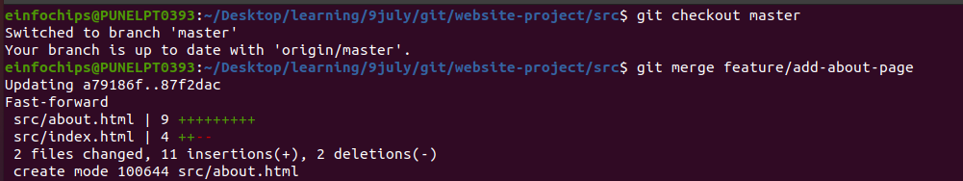
Here Fast-forward merge happen because there are no new commits on currrent branch
Exercise 3 : Rebasing
Rebase : change the base of branch
it move entire branch to begin from the tip of another branch

1) We rebase “ feature/update-homepage ” onto “ master ”

git checkout feature/update-homepage
git rebase main
the feature/update-homepage commits are moved on top of the latest commits from the master branch.

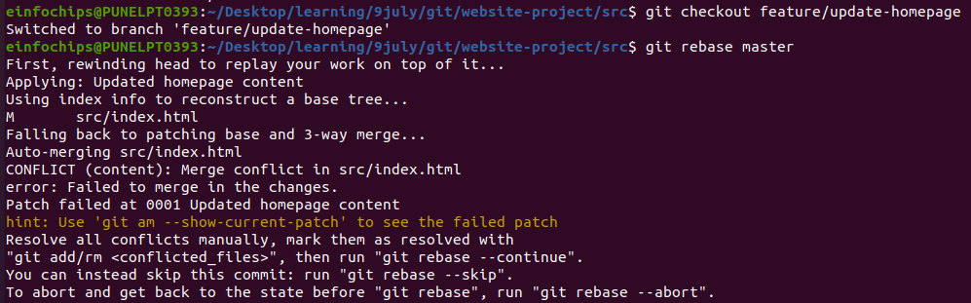

2) Resolve conflict which arise during rebase.

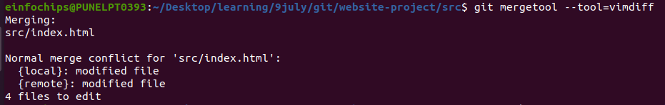

3) Push the rebase branch
git push -f origin feature/update-homepage

Exercise 4 :Pulling and collaboration

1) first we switch to master branch and then we check master branch is up-to-date

git checkout main
git pull origin main

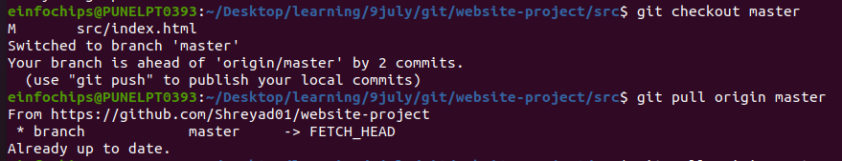

2) do some change on github repository
3) pull the changes made by the collaborator

git pull origin main
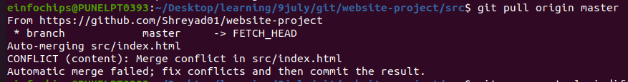
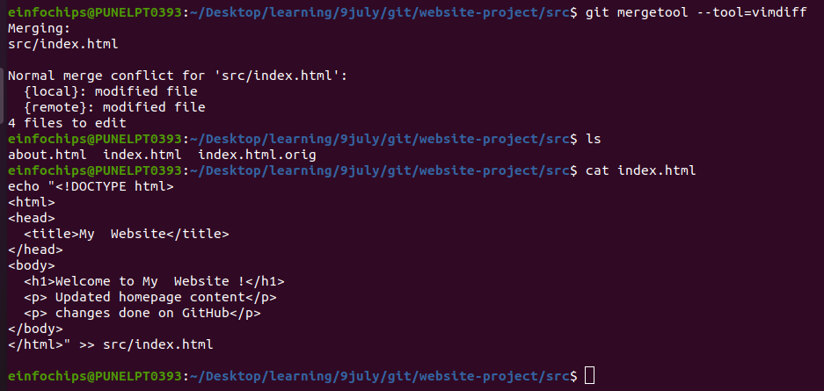
Exercise 5 : Versioning nd Rollback

1) Tag the current commit as “ v1.0 ”

git tag -a v1.0 -m "Version 1.0: Initial release"
git push origin v1.0

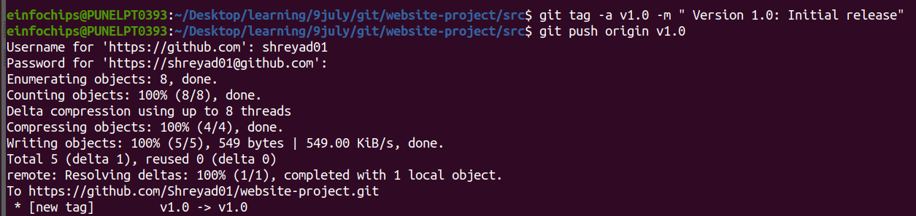

Make a change that needs reversion
1) update index file on features/update-homepage
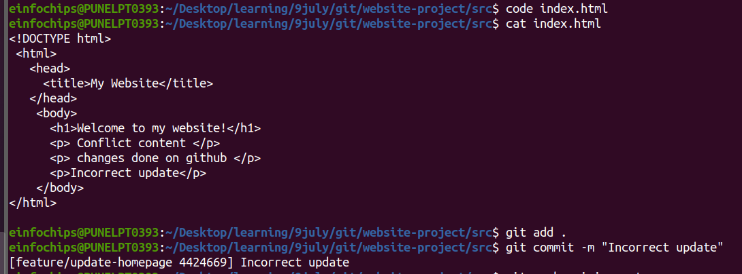

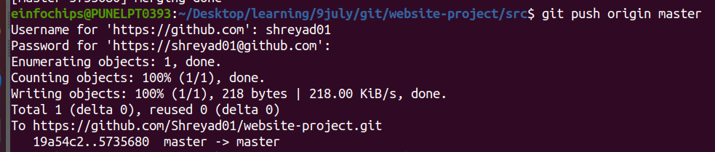
Revert to previous version

1) using revert we can undo the last commit

git revert HEAD
git revert : This command is used to create a new commit that undoes the changes made by a previous commit.
HEAD is a reference to the currently checked out commit, which in this case is the most recent commit on your current branch.

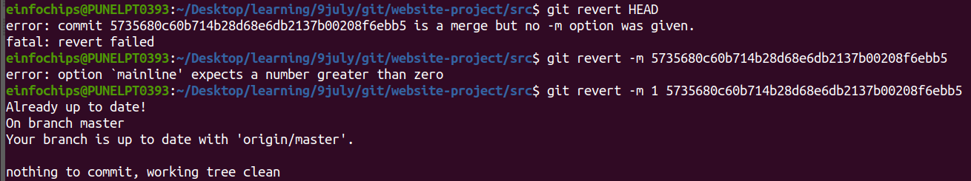
git push origin main
2) reset to a specific commit :
git reset : use to reset the current branch to a specific state
here we are moving HEAD pointer to point to specific commit (v1.0)
--hard : reset both working directory and staging area. It discard all changes in working directory and staging area that are not in commit being reset
git reset --hard v1.0
git push -f origin main
git push : This command is used to push commits from your local repository to a remote repository.
-f : this force git to perform the push operation.
This can be necessary in cases where you have rewritten history locally and need to update the remote branch accordingly.
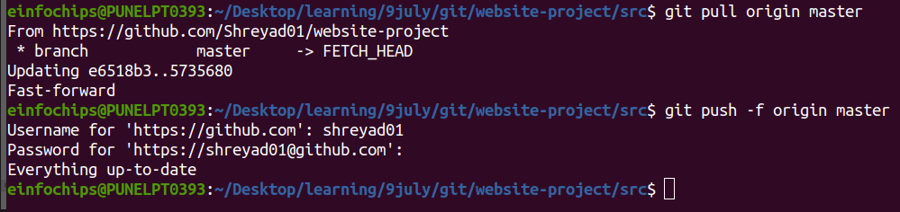
Stashing changes
git stash
1) git stash : It is used to temporarily store changes that are not ready to be committed yet.
It saves the modifications in working directory and staged changes onto a stack of stashes.

Apply the stashed changes:
git stash apply
1) git stash apply : command is used to apply the most recent stash from the stash stack back into your working directory.
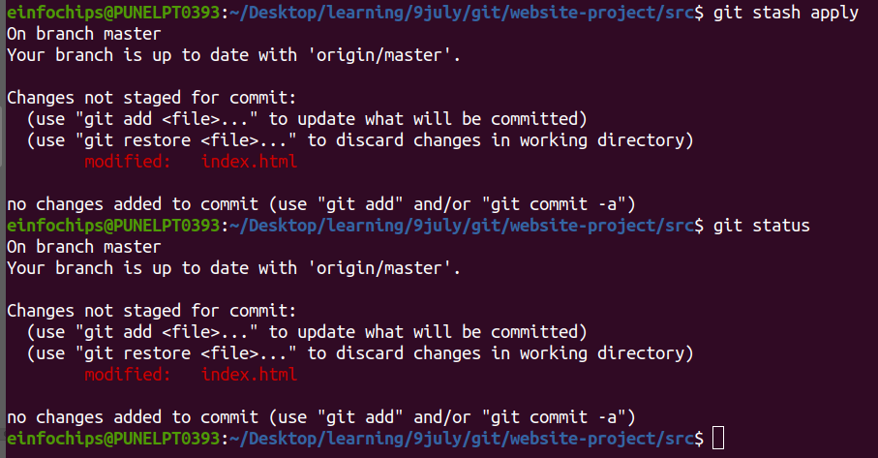
Viewing commit history :
use git log to view commit history :
git log -–oneline

git log –oneline : This command is used to display commit history in a single line format
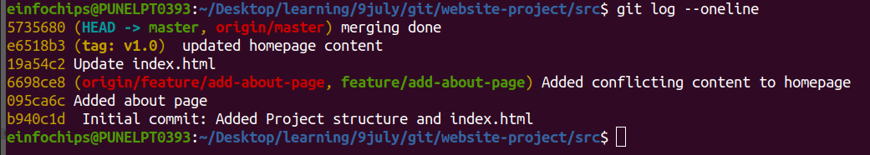
Cherry-Picking Commits :
Cherry-picking : Use to the process of selecting and applying a specific commit from one branch onto another branch.
This allows you to pick individual commits and apply them to your current branch,

1) create new branch “ feature/cherry-pick ” and cherry-pick commit from another branch :
git checkout -b feature/cherry-pick
git cherry-pick <commit-hash>
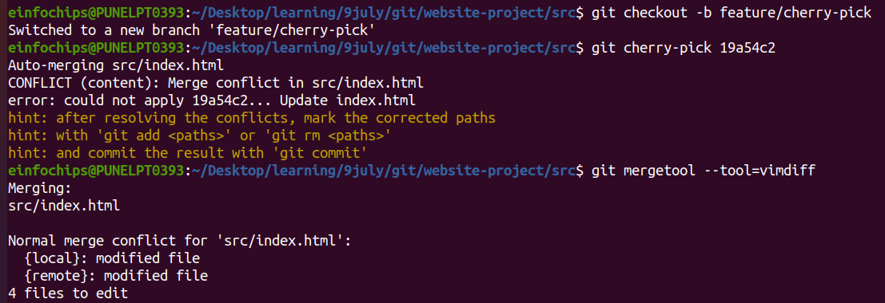

2) After resolving conflict use ” git Cherry-pick --continue ” to continue Cherry-pick
operation and push to remote repository .
git push origin feature/cherry-pick
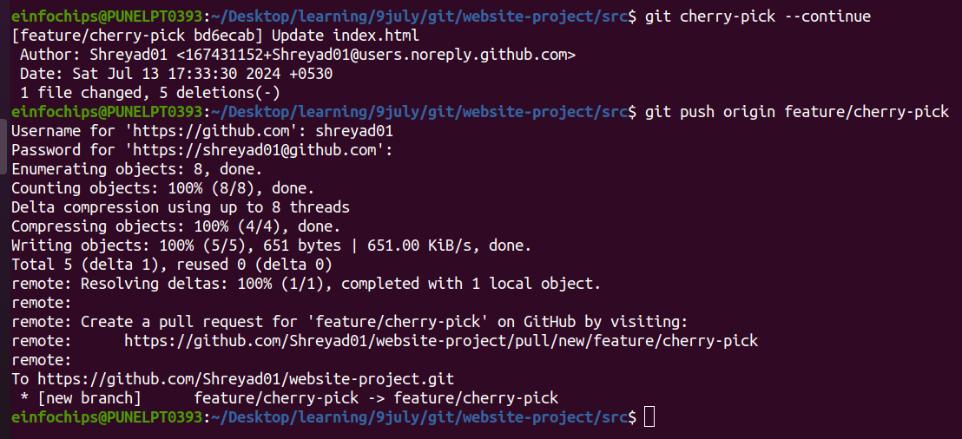
Interactive Rebase :
Use interactive rebase to sqash commits :
git checkout main
git rebase -i HEAD~3

git rebase -i HEAD~3 : This command use to reapply commit on top of HEAD~3 tip
Here -i = interactive : This enables the interactive mode , here we specify how git should reapply each commit
HEAD~3 : points to the commit that is three commits behind the current HEAD.
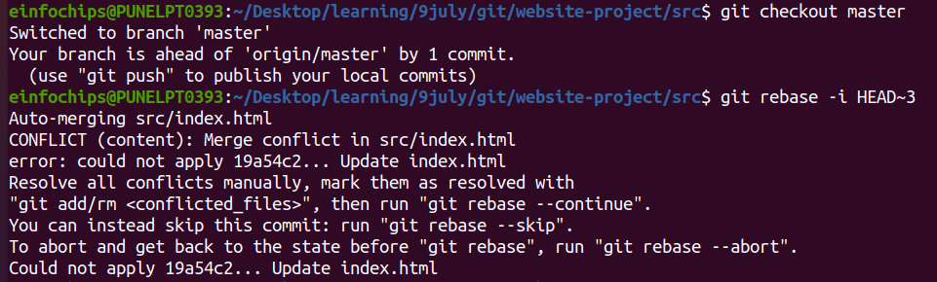
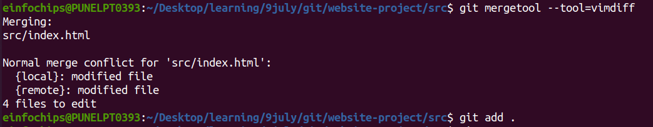
After merging conflict we continue rebase
